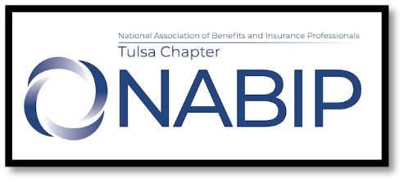
NABIP Tulsa
Virtual/4200 E Skelly Dr. 3rd Flr, Tulsa, OK 74135
Board Meeting Minutes
October 3, 2024 - virtual
x | Jennifer Helms – President |  | Jennifer Brittain –  Director | x | Kristan Carlton – Awards
x | Greg Holley –  Past President | x | Mike Stephens -  Trustee |  | Lisa Irby – Scholarship
x | Tim Brooks –  Pres Elect | x | James Ashford - Legislative | x | Andrea Blevins – Leg Co-Chair
x | Kristan Carlton –  Vice President | x | Cindy Ramirez –  Membership/Retention |  | – Public Service
 | Jennifer Brittain- Secretary | x | Eve Adams –  Media/Communications
x | Tim Brooks- Treasurer | x | Tim Brooks –  HUPAC
 | Brooke Riley – Director | x | Mike Stephens –  Professional Development
x | David Harder -  Director | x | Ryean Miller –  Hospitality

(Bold denotes Voting Board for 2024-2025)
Call to order 10:02; Jennifer H read anti-trust
Jennifer B could not be present and she gave her proxy to Ryean.
Old Minutes – September minutes, Kristain motioned to approve, Ryean 2nd, minutes passed
Treasurer Report – report attached, Tim reported everything will stay roughly the same and will between now and Jan with no meetings. Jan we should start to receive partner checks. Balance is at $10,963.41. CD matures on the 12th. $20k was original investment and we have accumulated $1,082.85 in interest. BOK has 4mo cd with 4.5% apy, would earn about $300. Greg motioned to put full $20k in 4 month CD, James 2nd, motion passed.
Membership/Retention – report attached, we have 139 members, Cindy is working with national on reporting as there seems to be a lot of ups and downs with our membership numbers.
Legislative – James reported there is not much going on with leg right now. They do expect telehealth extension to be included in bill and pass. Andrea reported that Connie is working with attorney on Insure OK
Professional Development – Mike will work on partners, James suggested Aetna and Global and Ryean suggested Thrive. Mike is working on Jan and Feb meetings.
Awards – Kristan is working on a roadmap for awards for next person. Still no response from national with feedback on awards. Jen H will email Kevin Trokey to see if he can help us get response.
Communications/Media/Website – Eve mentioned we have a media contact, Matt Scott. He may be able to help with social media posts.
HUPAC – Tim reported there will be 2 charges in State PAC because nothing was deducted in Sept.
Public Service – nothing to report
Hospitality – nothing to report, looks like we had 29 in attendance for Sept meeting. We will need to decide if we want to continue with Sept.
Scholarship – nothing to report

Old Business:
- TCC pricing - raised to $33 in March ($24.95+taxes & service charges), we are losing every meeting; they will come down to $22.95; are we going to raise to $30 until we secure new location? – James will reach out to his Tulsa Tech contact
- P&P for meeting refunds – we will work on next meeting

New Business:
• Social Media Chair – Welcome Allie
• Social – do we want to have one, if so where and when? Need to get something out ASAP – maybe do
something in Jan
• Cap Con – Katie, Cindi, Tim and Mike on Tulsa budget, James, Jennifer and Andrea also attending

Meeting Adjourned – at 11:11, Cindy motioned Greg 2nd.

