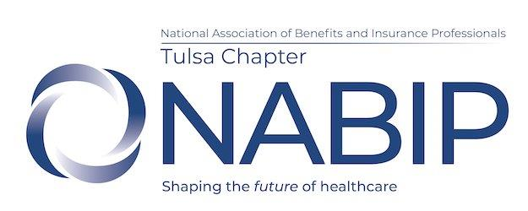

NABIP Tulsa Board Meeting Agenda
Thursday, June 6, 2024
10:00 – 11:00am Richmond Plaza

Board Meeting:
Minutes (May 2024) Jennifer Brittain/Jennifer Helms
Treasurer’s Report Tim Brooks
Chairperson Reports:
Membership Cindy Ramirez Legislative James Ashford
Professional Development Mike Stephens Awards Kristan Carlton
Communications/Media/Website Eve Adams
PAC Tim Brooks
Public Service
Hospitality Ryean Miller

Old Business:
Annual Convention – Jen H, Ryean and Eve attended for Tulsa and James for state
New members attending GMM at no cost – continue discussion

New Business:
Upcoming board leadership
Membership Conest – continue?
Have Sept GMM?
Half the Pot – CC charges will include the fee

Next Board Meeting – scheduled on 7/4, so we need to pick new date and confirm conference room is available

Next Monthly Luncheon – June 13, 2024 – NABIP OK Board meeting in OKC
June 20, 2024 – Business Meeting
July 18, 2024

