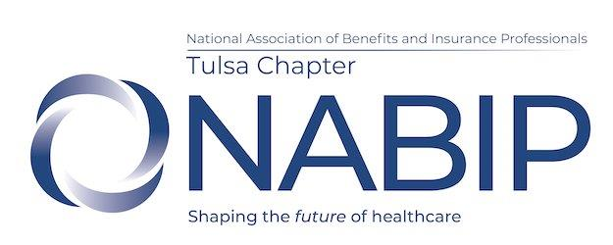

NABIP Tulsa Board Meeting Agenda
Thursday, March 6, 2025
Tulsa Tech 3638 S Memorial Dr, Tulsa, OK CSC Building/Virtual

Board Meeting:
Antitrust Statement
Minutes (Feb 2025) Jennifer Brittain/Jennifer Helms
Treasurer’s Report Tim Brooks
Chairperson Reports:
Membership Cindy Ramirez Legislative James Ashford
Professional Development Mike Stephens Awards Kristan Carlton
Communications/Media/Website Eve Adams
PAC Tim Brooks
Public Service
Hospitality Ryean Miller
Social Media Allie Lile
Scholarship Lisa Irby

Old Business:
- P&P for meeting refunds – attached
- Cap Con - Katie, Cindy, Tim; also attending James, Jennifer and Andrea
- Annual Convention – June 28-July 1, Miami – need to finalize attendees ($550 registration)

New Business:
- Need to confirm Expo – Tulsa Tech is available for Expo Aug 28th
- Contract and expense for Andy Neary, Symposium Speaker – sent contract in email
- Make up for Seth/Leg meeting?
- Next board year

Next Board Meeting now at Tulsa Tech – April 3, 2025, May 8, 2025 (note change to 2nd Thursday)
Next Monthly Luncheon now at Tulsa Tech – March 27, 2025, April 17, 2025 Symposium – starting in May meetings at Tulsa Tech

